Exercise 1: **BEHAVIOUR**

The hypotheses:

Adding trust-inducing copy on the email, phone and opt-in fields at checkout will lead to an increase in transactions.

Test run dates: 10/18/19- 10/31/19

Device : Desktop, Mobile

I am further exploring the New and Returning Users to see if the test results in increase in transactions or conversions.

Steps:

1. View- Test View
2. Select a date range. pre-event Oct 4th to Oct 17th :post-event- Oct 18th – Oct 31st
3. Pick segment : Returning Users
4. Pick segment : New Users

For each combination of Dimensions and Metrics, I am doing a descriptive analysis and also applying Linear Regression to the test period data to determine the statistical significance.

A linear regression is say like :

Y ~ aX1 + bX2 + cX3

The concept of Linear Regression is determining the proportion of variation of the dependent variable (Y), due to independent variable(predictors) X1 or X2 or X3.

P-values and coefficients(a, b or c) in regression analysis work together to tell which relationships in the model are statistically significant and the nature of those relationships.

The coefficients describe the mathematical relationship between each independent variable and the dependent variable. Each regression coefficient is independent of all the other predictors. If ‘a’ is positive, then for every one unit increase in X1, Y increase by ‘a’. On the other hand, if ‘a’ is negative, for every one unit increase in ‘a’, Y decreases by ‘a’ unit.

The null hypothesis of the model is that predictors are insignificant. If p- value is <0.05 it means that there is very less probability that the predictor is insignificant, so we reject the Null.

In the following analysis, I am considering p-values to determine the statistical significance for the predictors **in the test period.**

**Conversions: eCommerce**

**#1. New Users. Dimensions**: Channel, Page **Metrics**: Pageviews

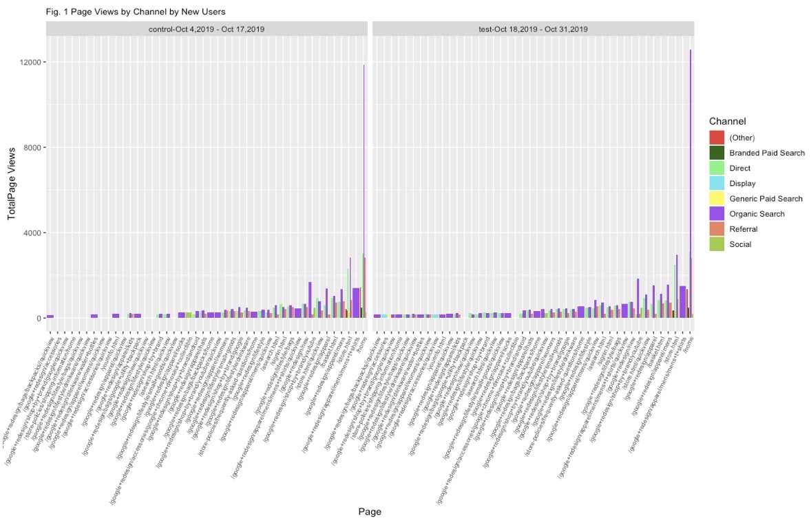

**Returning Users. Dimensions**: Channel, Page **Metrics**: Pageviews

Fig. A

Among the New Users, in the test period, Direct and Organic Channel search seems to be more prevalent and in Returning Users, Referral and Organic Search are more commonly used Channels for Page Views. In the test period, Pages related to lifestyle, apparels and accessories are statistically significant.

**#2. New Users. Dimensions:** Page(Electronic Products) **Metrics:** Pageviews

**Returning Users. Dimensions:** Page(Electronic Products) **Metrics:** Pageviews

The test period has an increase in the page views of Electronic products for the New Users. The page views drops for Returning Users, however, Electronic products as chargers gain more page views.

**#3. New Users. Dimensions:** Page(Office Products) **Metrics:** Pageviews

**Returning Users. Dimensions:** Page(Office Products) **Metrics:** Pageviews

The Page views and various pages of Office Products increased in the test period for both New and Returning Users. Pages as redesign office, laptop and cell phone stickers and metallic notebook has the maximum pageviews.

**#4. New Users. Dimensions:** Page (Drinkware Products) **Metrics:** Pageviews

**Returning Users. Dimensions:** Page (Drinkware Products) **Metrics:** Pageviews

In product type Drinkwares, water bottles, mugs, tumblers and thermal cups had most page views in the test period for Users.

**#5. New Users. Dimensions:** Page(Bag Products) **Metrics:** Pageviews

**Returning Users. Dimensions:** Page(Bag Products) **Metrics:** Pageviews

The Bag products as backpacks, incognito messenger bags, flat front grey bags seem to have the maximum page views. Page views for Incognito zip pack drastically fell for both New and Returning users in test period.

**#6. New Users. Dimensions:** Page(Lifestyle Products) **Metrics:** Pageviews

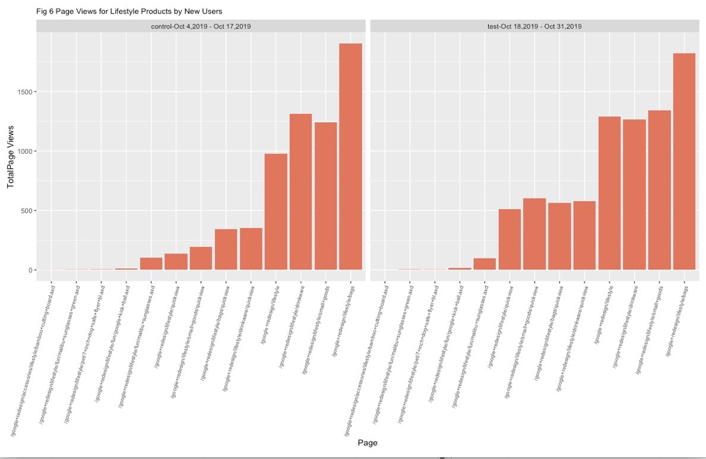

**Returning Users. Dimensions:** Page(Lifestyle Products) **Metrics:** Pageviews

Lifestyle Products gained more page views for both New and Returning users in test period. Lifestyles products as Bags, Drinkware and small goods had the maximum page views.

**#7. New Users.**  **Dimensions:** Page(Apparel Products) **Metrics:** Pageviews

**Returning Users.**  **Dimensions:** Page(Apparel Products) **Metrics:** Pageviews

Apparel maintained more page views and pages in the test period. Men’s apparel apparently had maximum page views.

**#8. New Users. Dimensions:** Page(Product not set) **Metrics:** Pageviews

**Returning Users. Dimensions:** Page(Product not set) **Metrics:** Pageviews

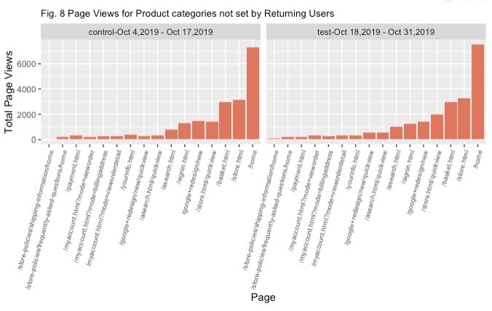

Product “notset” did not have any distinguishing differences in test period compared to control period.

**#9. New Users. Dimensions:** Page, Brands(Landing Content Page) **Metrics:** Pageviews

**Returning Users. Dimensions:** Page, Brands(Landing Content Page) **Metrics:** Pageviews

Brands did not have any distinguishing differences in test period compared to control period.

**INFERENCE:**

Lifestyle and apparel products are statistically significant in the test period on Pageviews. In the Apparel products, men’s apparel was the most viewed. Among the Lifestyle products, bags, drinkware sand small goods had significant effect on variations in Page Views (Fig. A).